Nama : Fina Maulidiyah N

NIM : 19051397034

Prodi : D4 Manajemen Informatika A

SOAL

1. Binary Tree

* Pohon biner dengan ketentuan sbb :

Ancestor (M) = Z, X

Descendant (Y) = K, L

Parent (N) = Z

Child (Z) = M, N

Sibling (Y) = Z

Size = 7

Height = 3

Root = X

Leaf = K, L, M, N

Jawab :

X

Y

Z

M

K

L

N

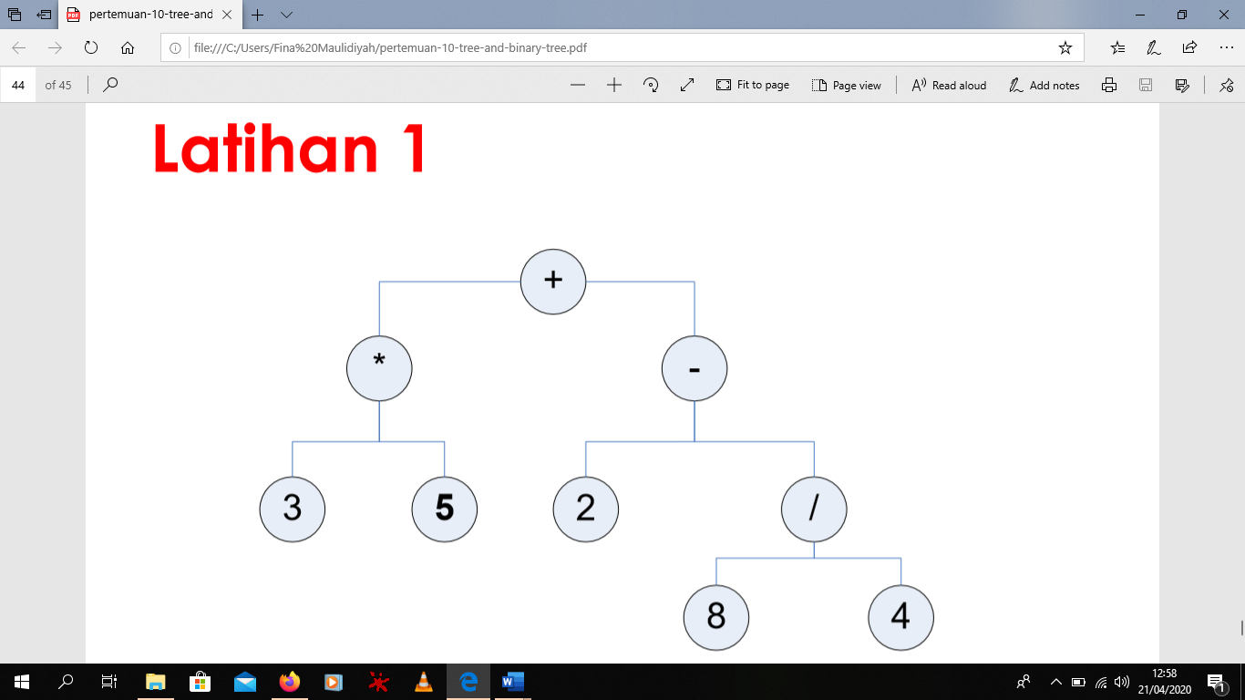

* + PreOrder = + \* 3 5 - 2 / 8 4
  + InOrder = 3 \* 5 + 2 - 8 / 4
  + PostOrder = 3 5 \* 2 8 4 / - +

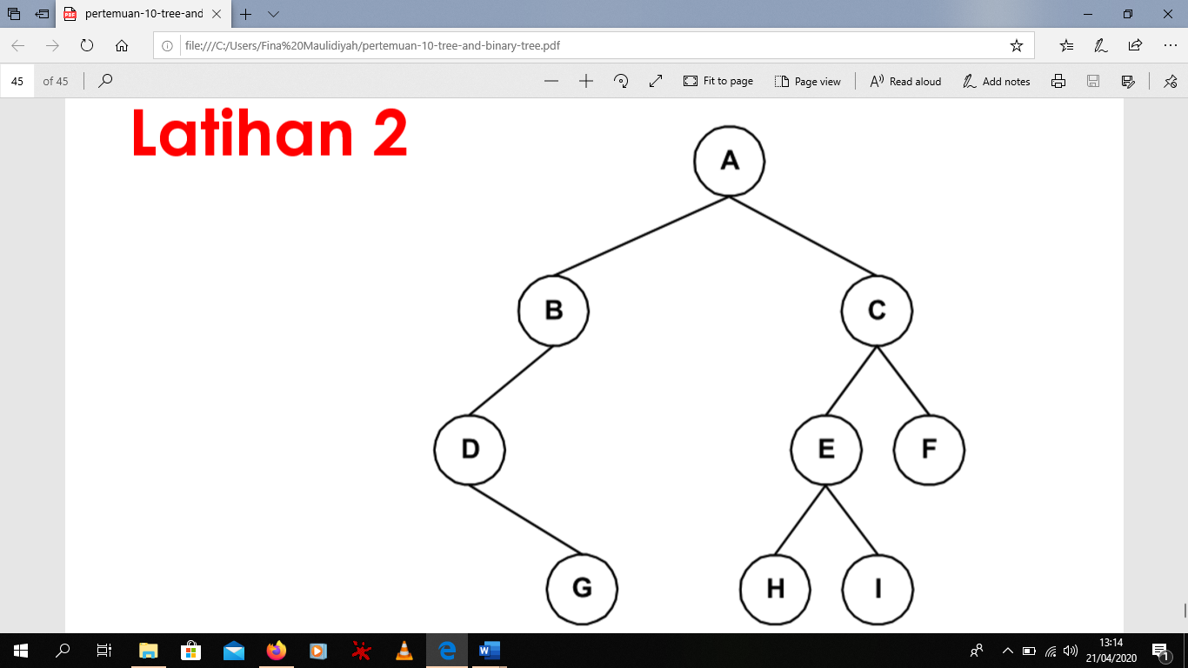

* + PreOrder = A B D G C E F H I
  + InOrder = G D B A H E I C F
  + PostOrder = G D B A H I E F C

1. Tree

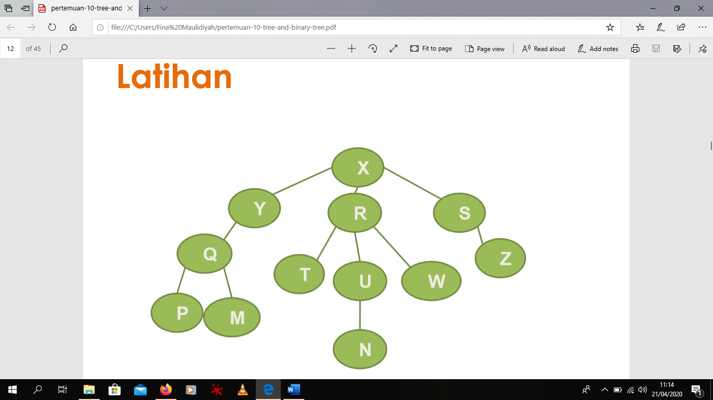

* Ancestor (N) = U, R, X

Descendant (Y) = Q

Parent (Z) = S

Child (Q) = P, M

Sibling (U) = T, W

Size = 12

Height = 4

Root = X

Leaf = P, M, T, N, W, Z

Degree (R) = 3

* Level 0 = X

Level 1 = Y, R, S

Level 2 = Q, T, U, W, Z

Level 3 = P, M, N

* Notasi Kurung

(X(Y(Q(P, M))), (R(T, U(N), W)), (S(Z))

* Notasi Tingkat

X

Y

Q

P

M

R

T

U

N

W

S

Z

* Diagram Venn

T

Z

P

W

Q

S

R

Y

X

N

M

U